**COMSATS University Islamabad,   
Abbottabad Campus**

**Project Proposal   
(SCOPE DOCUMENT)**

**for**

**<PROJECT NAME>**  
Version 1.0

***By***

**Student Name 1 CIIT/SP09-BCS-xxx/ATD**

**Student Name 2 CIIT/SP09-BCS-xxx/ATD**

***Supervisor*Supervisor Name**

***Bachelor of Science in Computer Science (20xx-20xx)***

|  |  |  |
| --- | --- | --- |
| **No.** | **Comment** | **Action** |
|  |  |  |
|  |  |  |
|  |  |  |
|  |  |  |
|  |  |  |
|  |  |  |

**SCOPE DOCUMENT REVSION HISTORY**

**Supervisor Signature**

**Date:**

**Table of Contents**

**1.** **Introduction 4**

**2.** **Problem Statement 5**

**3.** **Problem Solution for Proposed System 5**

**4.** **Related System Analysis/Literature Review 5**

**5.** **Advantages/Benefits of Proposed System 5**

**6.** **Scope 6**

**7.** **Modules 6**

7.1 Module 1: Module Name 6

7.2 Module 2: Module Name 6

**8.** **System Limitations/Constraints 6**

**9.** **Software Process Methodology 6**

**10.** **Tools and Technologies 7**

**11.** **Project Stakeholders and Roles 7**

**12.** **Team Members Individual Tasks/Work Division 8**

**13.** **Data Gathering Approach 8**

**14.** **Concepts 8**

**15.** **Gantt chart 9**

**16.** **Mockups 10**

**17.** **Conclusion 11**

**18.** **References 11**

**19.** **Plaragism Report 11**

**Project Category: (**Select all the major domains of proposed project**)**

* **A-**Desktop Application/Information System **B-**Web Application/Web Application based Information System **C-** Problem Solving and Artificial Intelligence ** D-**Simulation and Modeling ** E-** Smartphone Application ** F-** Smartphone Game ** G-** Networks ** H-** Image Processing****Other (specify category) ______________________

**Abstract**

The project aims to develop an innovative application for the early detection of Parkinson's disease using drawing analysis. By analyzing drawings, the project aims to create application for the early diagnosis of Parkinson's disease. Using machine learning and current technology, the application will examine small changes in a person's drawing styles, which can act as early signs of Parkinson's disease. The application will provide a user-friendly and accessible platform for people to check their motor abilities and get early warnings about suspected symptoms of Parkinson's disease by integrating this diagnostic tool in the flexible Flutter framework.

**Introduction**

The goal of our project is to identify Parkinson's disease (PD) early using an innovative technique called drawing analysis. Parkinson's is a neurological disorder that increases, and early detection is essential for successful treatments. To do this, we will collect a wide range of drawing samples, including both Parkinson's patients and healthy people. We will train a model to identify minor variations in drawing patterns that may indicate early-stage PD by using machine learning technologies.

Our project is user-friendly mobile application, created using the flexible Flutter framework. Users of this application will be able to quickly submit images or drawings on the screen of mobile to a server where our trained model will do real-time analysis. Users will get fast feedback based on their drawing styles on possible signs of Parkinson's disease. Our application also has an offline mode that enables users to draw directly on their mobile screens, assuring accessibility even when there is no internet connection. By providing a low-cost, simple instrument that can promote early detection and improve disease management, our project aims to make easier early Parkinson's disease detection.

**Problem Statement**

The goal of our project is to address the Parkinson’s disease on early stages. The problem of early Parkinson's Disease (PD) detection is addressed by our program. Parkinson's disease is a progressive neurological disorder, and early detection is essential for effective treatment and better patient outcomes. However, current diagnostic techniques may be costly and harm, and they might not catch the illness in its early stages. Many people wait until their symptoms have gotten much worse before they seek medical attention. Our approach is to offer a harmless, cost-effective, and generally available tool for early PD identification, enabling people to keep track of their health and seek medical treatment at the earliest signs of the disease.

We are developing this system to solve an important healthcare gap. Millions of individuals throughout the world suffer with Parkinson's Disease, a severe disorder whose early discovery can greatly enhance a patient's quality of life. Delay in diagnosis is a result of the absence of easily accessible, harmless technologies for early Parkinson's disease detection. We want to develop a solution that enables people to continuously track their health and identify potential PD symptoms at an early stage by using the power of modern technology, machine learning, and a user-friendly mobile  application. The goal of this project is to simplify healthcare by enabling everyone to obtain early PD diagnosis, which will eventually enhance patient outcomes and disease treatment.

We will learn skills like machine learning and data analysis, software development using Flutter, data collection and management, mobile app development, problem-solving, collaboration, domain knowledge in Parkinson's Disease, project management, UI/UX design, understanding ethical considerations in healthcare and technology. This project offers a whole learning experience that includes both hard and soft skills, which are crucial in the sectors of data science, technology, and healthcare.

**Problem Solution for Proposed System**

The proposed system for early Parkinson's disease (PD) detection using drawing analysis efficiently. It is a harmless, low-cost approach, removing the financial and physical barriers associated with many traditional medical tests. The method may correctly recognize drawing pattern abnormalities that may indicate early-stage Parkinson's disease (PD) by using machine learning technologies allowing for immediate treatment and better outcomes for patients.

In addition, the solution promotes accessibility by providing a user-friendly mobile app that uses the Flutter framework. This application allows users to upload images and drawings for server-based analysis, allowing them to continuously track their health. The addition of an offline mode means that the tool may be utilized in regions where internet availability is limited or non-existent. By solving these issues, the approach simplifies early Parkinson's disease detection, making it more widely available and possibly reducing healthcare disadvantages, resulting in improved patient outcomes and treatment for the disease.

**Related System Analysis/Literature Review**

**Write** about the existing/similar systems related to your proposed project. **At least three** existing systems should be discussed.

Don’t use more than 4 sentences for explaining a single system/application.

Briefly explain the related system analysis which help to specify the contribution of the proposed project.

(**Note**: Research based projects may provide literature review instead of related system analysis.)

**Table 1 Related System Analysis with proposed project solution**

|  |  |  |
| --- | --- | --- |
| **Application Name** | **Weakness** | **Proposed Project Solution** |
| The name of related application(s). | Weaknesses may include limited features, low quality functionality and processes. | The way the proposed project mitigates the weaknesses. |

**Advantages/Benefits of Proposed System**

* The device may detect small changes in drawing patterns linked with early-stage Parkinson's disease, allowing for earlier medical treatment. Early detection leads to better treatment results and a higher quality of life for Parkinson's disease patients.
* Unlike many traditional detection methods, this technology is harmless and low-cost, making it available to a larger population. It does away with the necessity for costly medical tests or treatments.
* The system offer offline mode allows users when they are not connected to the internet, guaranteeing accessibility in distant or less fortunate locations.
* The method helps to reduce gaps in healthcare by offering an easy and affordable tool for early PD detection. It enables people to take care of their health and seek immediate medical care, regardless of where they live or how much money they have.
* The mobile application is designed for ease of use, allowing people with a variety of technical backgrounds to self-assess their motor abilities. The user-friendly interface increases user engagement.

**Scope**

The main scope of our project is use in the medical field, especially in neurology and disease detection. It may be used by medical professionals as an additional tool for early detection of Parkinson's disease and integrated into medical treatments. The system expands into the area of preventative health by allowing individuals to monitor their motor abilities and seek medical treatment at the first symptoms of Parkinson's disease, so contributing to a proactive approach to health management. The system can be described as digital health since it detects diseases using modern technology, machine learning, and mobile application development. The system's goals include increasing access to early PD diagnosis for a broader population, perhaps reducing healthcare inequality and guaranteeing that people living in rural or underprivileged locations may use this diagnostic tool. To increase awareness of Parkinson's disease and the value of early detection, the government might include the system in initiatives related to public health. This may result in more people learning about the condition and encouraging them to keep an eye on their health. Early detection of PD can lead to more cost-effective healthcare. By detecting and treating Parkinson's disease in its early stages, the government might possibly reduce the financial burden on public health systems and save money on long-term healthcare costs.

**Modules**

Write down the modules of the proposed project. Don’t forget to mention special/new features. Briefly explain your one module in 6 to 8 sentences.

(Note: Usually 5-6 Modules for 2 student’s projects and 8-9 modules for 3 student’s project)

**Explanation of a Module:** Module is a section of a program that performs a task. Programs consist of [modules](http://www.webopedia.com/TERM/M/module.html), each of which contains one or more routines. The term routine is synonymous with procedure, function, and subroutine.

Example:

*Enterprise resource planning (ERP) software - is comprised of several large modules (for example, finance, supply chain and payroll, etc.), which may be implemented with little or no customization.*

(Briefly explain each module with respect to major functionality in user context)

**Module 1: Data Collection**

* Collecting drawings and relevant user data to make a dataset
* Cleaning and organizing the collected data for further analysis

**Module 2: Machine learning model**

* In this module we will develop a machine learning model
* Train the modal using the available dataset

**Module 3: Server deployment module**

* Deploy the trained machine learning models on a server.
* Set up API endpoints for receiving and processing image data from the mobile application.

**System Limitations/Constraints**

Write down the limitations and constraints of the proposed project.

(Usually 2-4 constraints)

**Software Process Methodology**

Write down your software methodology/ software process that will be used for project development. .Also mention why you have chosen this methodology. (Usually 3-5 sentences)

1. You can use Object Oriented Methodology, or Procedural methodology.
2. Choice of methodology will affect choice of tools and technologies
3. Choice of methodology will affect nature of design (SDS)
4. Choice should be made depending on your expertise and your needs e.g. most simulation and device level software can only be programmed in procedural languages.

**Tools and Technologies**

Mention all the hardware/software tools and technologies with version number which will be used in implementation of the project. Write about the APIs, language(s), SDK(s) etc. which you will use for implementation.

Example:

**Table 2Tools and Technologies for Proposed Project**

|  |  |  |  |
| --- | --- | --- | --- |
| **Tools**  **And**  **Technologies** | **Tools** | **Version** | **Rationale** |
| MS Visual Studio | 2015 | IDE |
| MS SQL Server | 2015 | DBMS |
| Adobe Photoshop | CSC 6 | Design Work |
| MS Word | 2015 | Documentation |
| MS Power Point | 2015 | Presentation |
| Pencil | 2.0.5 | Mockups Creation |
| **Technology** | **Version** | **Rationale** |
| C# | 6.0 | Programming language |
| SQL | 2013 | Query Language |
| Html | 5 | Web Development |

**Project Stakeholders and Roles**

Write down the project stakeholders and their roles.

**Table 3Project Stakeholders for Proposed Project**

|  |  |
| --- | --- |
| **Project Sponsor** | All web applications and desktop applications should have real client. Mention your project sponsor.  Default option will be: COMSATS University, Islamabad |
| **Stakeholder** | Mention your stake holders with their roles and responsibilities.  Default option will be:   * Students names * Project Supervisor Name: Mr./Miss … * Final Year Project Committee: Evaluation of project |

**Team Members Individual Tasks/Work Division**

**Table 4Team Member Work Division for Proposed Project**

|  |  |  |
| --- | --- | --- |
| **Student Name** | **Student Registration Number** | **Responsibility/ Modules** |
| Student 1 Name | Student 1 Registration Number | Describe the work division of each  student along with modules  E.g.  Mr. Ali (Module1-Module3)  Augmented reality and Databases tasks. |

**Data Gathering Approach**

Write down information and requirement gathering approaches for proposed project e.g. Interview, Questionnaire etc. (Usually 3-5 sentences)

**Concepts**

Mention the concepts that you will learn while doing the proposed project.

For example: Augmented Reality, Virtual Reality, Algorithms, API’’s Code injection, Closures, VI technique etc.

Not more than 4 sentences for one concept. (Usually 3-5 concepts are briefly mentioned)

Example:

*Concept-1: Concept Name E.g. Augmented Reality (Briefly give the overview of concept with respect to your project)*

**Gantt chart**

Create the Grant Chart and provide estimated start and end dates of all proposed modules/tasks for each team member. Also identify the dependencies (which tasks cannot be started/completed, until the dependent task is completed). Gantt chart can be created using MS Project.

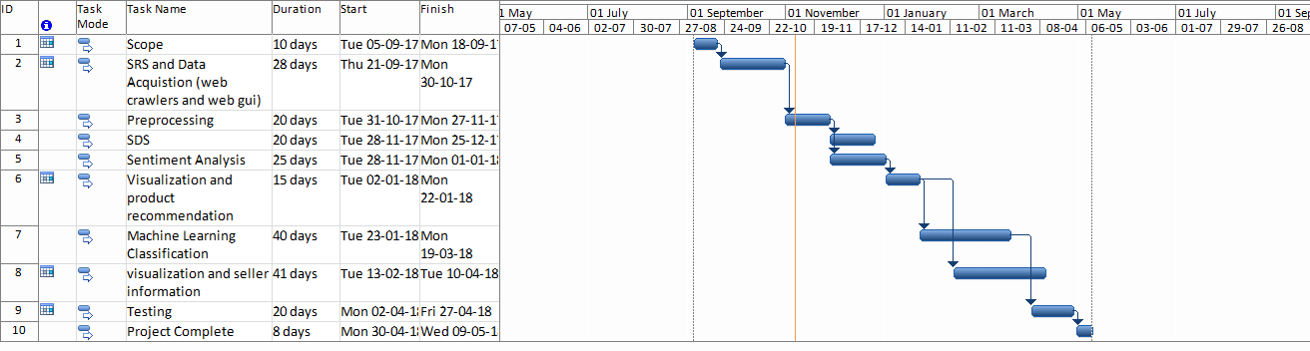

Figure 1Sample Gantt chart

**Mockups**

Insert minimum mockups (Usually 4-6 mockups) which show the major modules mentioned in the scope section of the document. Do not include mockups for Login, Signup, Forgot Password, Contact Us, About Us etc. If the project is a Web or a Smartphone Application, then include at-least three mockups from each part of the project. You can design mockup in any design tool for example pencil tool (<https://pencil.evolus.vn/>) or Balsamiq (<https://balsamiq.com/>)

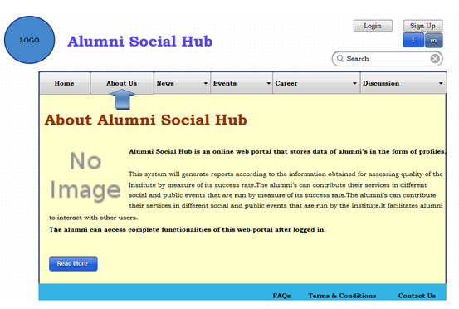

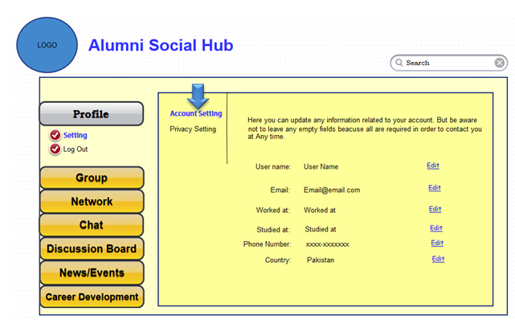

**Conclusion**

Conclude this document. (Usually 4-5 sentences)

**References**

Mention the books, research papers, web links etc.

**Plagiarism Report**

Attach the Plagiarism report of your project scope document from library staff of turnitin tool (http://turnitin.com